Navid Hariri, Summeeyah Haq, Juyoung Suh, Junjie Xiao, Shonda O’Conner

information systems 441  Professor Davoudian

Cool cars company

Contents

Introduction 4

Case Scenario 4

Business Needs 4

Requirements 4

Functions 5

Activities 5

Purpose 6

Relationship Matrix 7

Enhanced Entity Relationship Diagram 9

Business Rule 10

Referential Integrity Constraint 12

Functional Dependency Diagram and Normalization 13

Structured Query Language 16

Creation Script 16

Insertion 19

Customer 19

Domestic Customer 20

International Customer 20

Employee 21

Employee Skills 22

Sales Person 23

Mechanic 24

Vehicles 24

Order 25

Order Line 26

Supplier 27

Part 28

Service 28

Queries and Result 29

List All Domestic Customers 29

List all the employee IDs, names, and dates of employees who were hired before the end of May 2015 30

List all employee ID and names of employees who have more than 2 skills 30

List all Japanese customers 31

List customer ID, customer name, customer type, and how many orders each customer placed 32

Which vehicle ID, make, model, year, are priced above the average cost of our cars, and how much are they? 33

Find out vehicle make, model which were made after 2015, and all the service info from the vehicle and service table. 33

Which mechanic has an hourly rate of higher than $40, and works with parts that cost less than $3,000 and what are those parts called? List Mechanic employee ID and hourly rate 34

Find out the sales person's average rate of commission of total vehicle cost 34

How many cars are priced less than the average price of our cars? 35

What percentage of cars are priced less than the average price? Round to 2 decimal places. 35

# Introduction

Case Scenario

Cool Car Company is a company that has been around for many years specializing in selling vehicles. However, as the years went on, competition had risen, and other companies were responding faster than Cool Car Company in adopting more recent technologies, which resulted in less errors and cost and higher sales for them. Much of this issue seemed to have been caused by the company’s usage of the outdated traditional file processing system. The traditional file processing system has its disadvantages of program data dependence, duplication of data, limited sharing, lengthy development time, and high program maintenance. Having identified this as their primary issue, Cool Car Company went forward to implement a database approach for the company. The database approach has its many advantages to help the company such as program data independence, planned redundancy of data, improved data consistency, better data sharing and more.

## Business Needs

With the product line being the place where most companies compete with one another, Cool Car Company finds it crucial to be able to keep track of their revenue and expenses correctly and effortlessly. They are requesting a system to be able to identify the types of customers they have, the salespeople who sell these vehicles, the types of vehicle they sell, and the services provided for those vehicles by mechanics.

## Requirements

The management system should deploy a centralized database as a core to store, manage, and operate data. The database itself should be independent which only the database management system (DBMS) has the accessibility to the database. The DBMS connects with users’ applications as well. The entities in the database all should relate to the business. Each entity should have a unique name. The entities in the business should be logically related. The relationship between the entities should represent the exact business activities.

## Functions

The system will function to show what types of customers Cool Car Company has and what types of employees are selling or working on their vehicle. Also, the system will give detailed descriptions about the vehicles make, model, year, and cost as well as the orders made by customers. It will also function to show the services provided to each vehicle by the, mechanic

## Activities

The database administrator has access to data definition language in order to create, alter, and drop tables. These privileges are granted to the database administrator as he or she would be most knowledgeable about constructing and organizing the database. He and the other developers also have access to the data manipulation commands to insert, update, modify, and query the database. The other developers need to be able to take user data from the frontend and insert, update, or delete records in the database.  
Entities

The entities that are needed to create the system are Customer supertype with subtypes of International and Domestic subtypes. Employee supertype with Mechanic and Salesperson subtypes. Vehicle, Order, and Order Line, which will serve as an associative entity between Vehicle and Orders. Service entity will serve as an associative entity of Vehicle and Mechanic, Part, and Supplier.

## Purpose

The purpose of this technological shift to the database approach is to keep track of revenue and expenses accurately and effortlessly, which will then help Cool Cars Company continue to be competitive in the market and continue to have highly satisfied and happy customers.

# Relationship Matrix

|  |  |
| --- | --- |
| **Entity Types** | **Attributes** |
| **Customer** | Customer ID (PK) |
|  | Customer Name |
|  | Customer Phone Number |
|  | Customer Address  (Street, City, State, Zip Code) |
| **Domestic Customer** | State |
| **International Customer** | Country |
| **Employee** | Employee ID (PK) |
|  | Employee Name |
|  | Employee Phone Number |
|  | Employee Email |
|  | Date Hired |
|  | {Skill} |
| **Salesperson** | Commission |
| **Mechanic** | Hourly Rate |
| **Vehicle** | Vehicle ID (PK) |
|  | VehicleName |
|  | Vehicle Cost |
| **Order** | Order ID (PK) |
|  | Order Placement Date |
|  | Order Shipment Date |
| **Order Line** | Order Line ID (PK) |
|  | Vehicle ID (FK 1) |
|  | Order ID (FK 2) |
|  | Order Quantity |
| **Service** | Service ID (PK) |
|  | Vehicle ID (FK 1) |
|  | Mechanic ID (FK 2) |
|  | Service Name |
|  | Service Date Started |
|  | Service Date Ended |
| **Part** | Part ID (PK) |
|  | Part Name |
|  | Part Price |
| **Supplier** | Supplier ID (PK) |
|  | Supplier Company Name |
|  | Supplier Number |
|  | Supplier Address  (Street, City, State, Zip Code) |

# Enhanced Entity Relationship Diagram

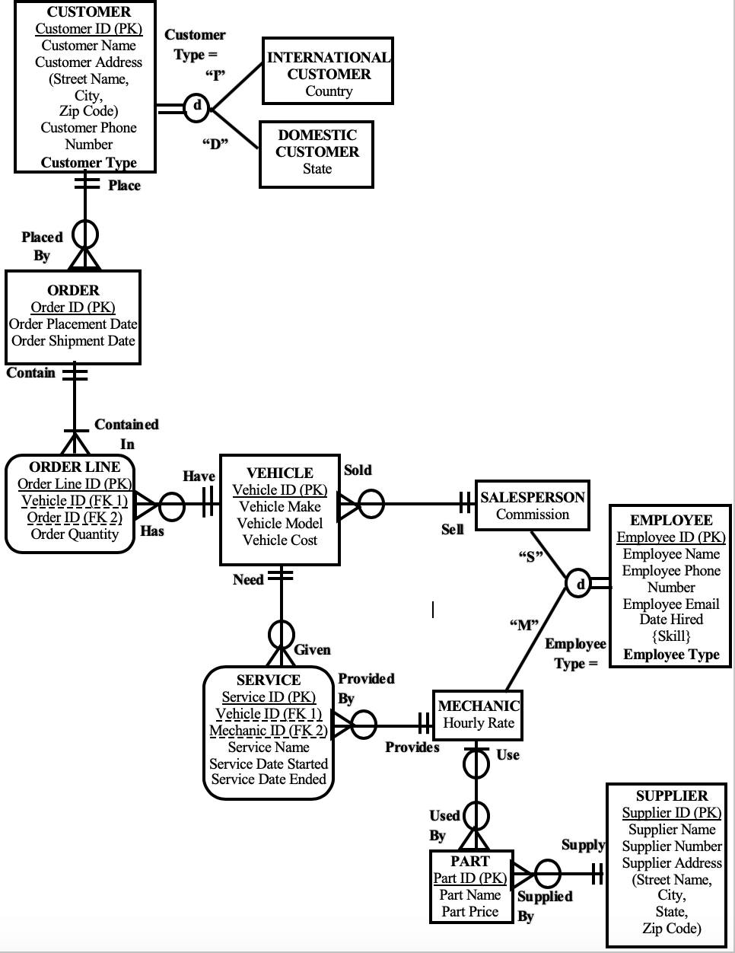

# Business Rule

1. Each CUSTOMERmust be a DOMESTIC CUSTOMER or an INTERNATIONAL CUSTOMER but never both at the same time.
2. Each CUSTOMER may place one or more ORDERS**.** Each ORDER is placed by one and only one CUSTOMER.
3. Each ORDERmust contain one or more ORDER LINES. Each ORDER LINE must contain in one and only one ORDER.
4. Each ORDERmust include one or more VEHICLES**.** Each VEHICLEmay be included in one or more orders.
5. Each ORDER LINE has one and only one VEHICLE**.** Each VEHICLEmay have one or more ORDER LINES.
6. Each EMPLOYEEmust be a SALESPERSONor a MECHANIC but never both at the same time.
7. Each VEHICLE may be worked on by one or more MECHANICS. Each MECHANIC may work on one or more VEHICLE.
8. Each VEHICLEmay need many types of SERVICE**.** Each SERVICEmust be given to one and only one VEHICLE.
9. EachSERVICE must be provided by one and only one MECHANIC**.** Each MECHANICmay provide many SERVICES.
10. Each SALESPERSON may sell one or more VEHICLE**.** Each VEHICLEmust be sold by one SALESPERSON**.**
11. Each MECHANIC may use one or more PARTS**.** Each PART may be used by one and only one MECHANIC.

Each PARTmust be supplied by one and only one SUPPLIER**.** Each SUPPLIERmay supply one or more PARTS.

# Referential Integrity Constraint

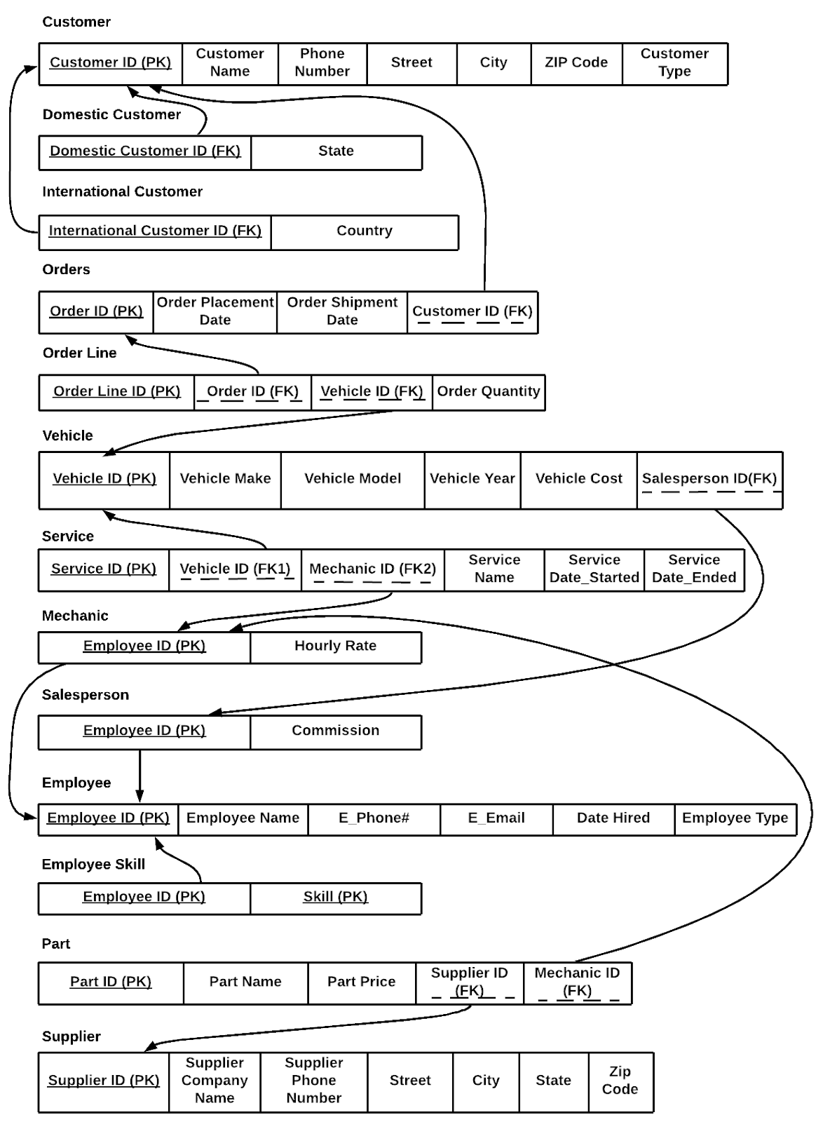

# Functional Dependency Diagram and Normalization

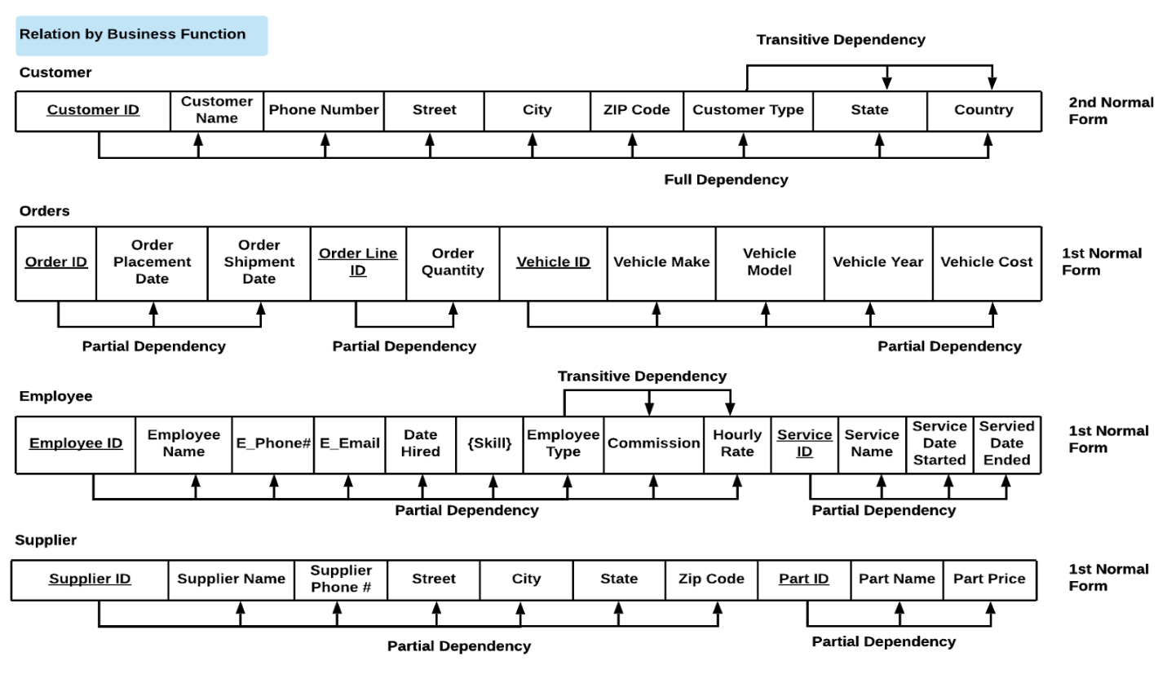

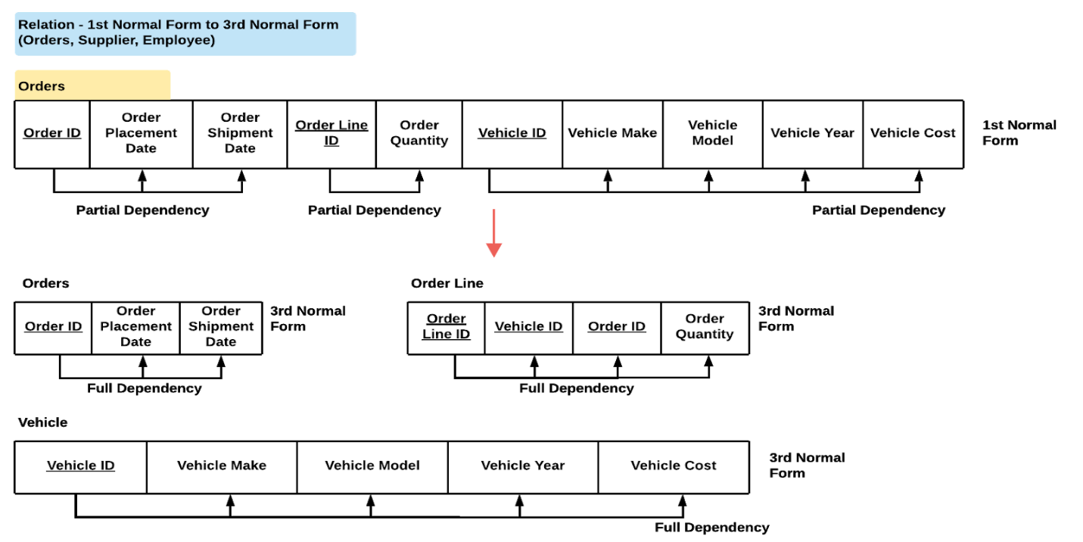

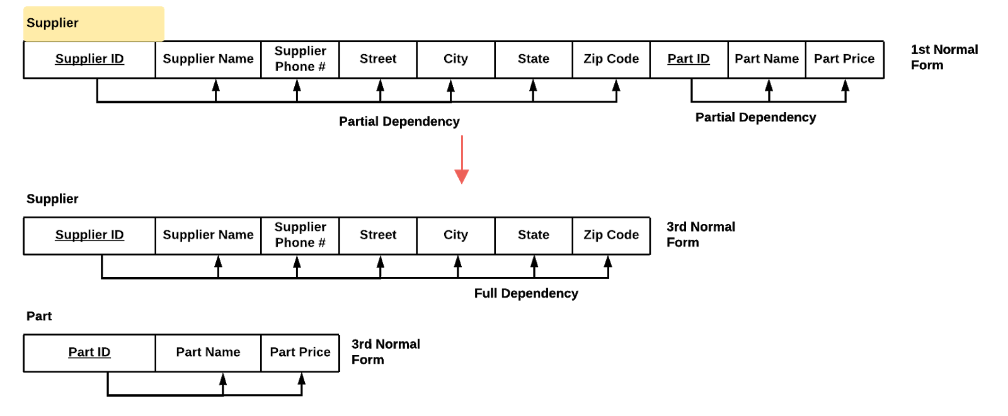

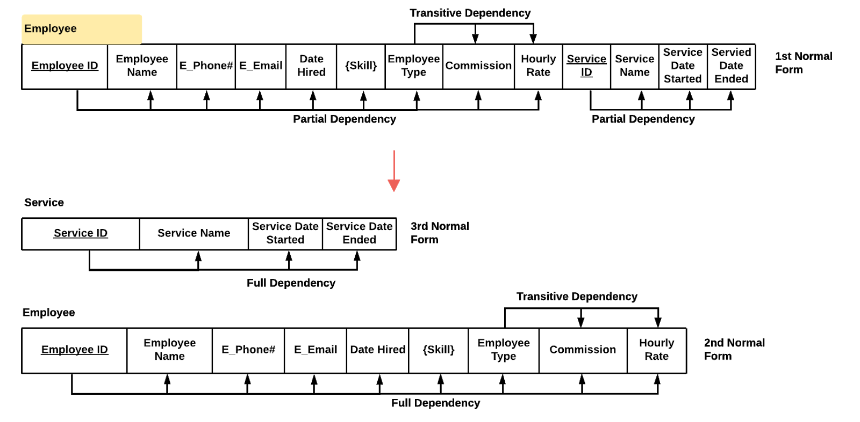

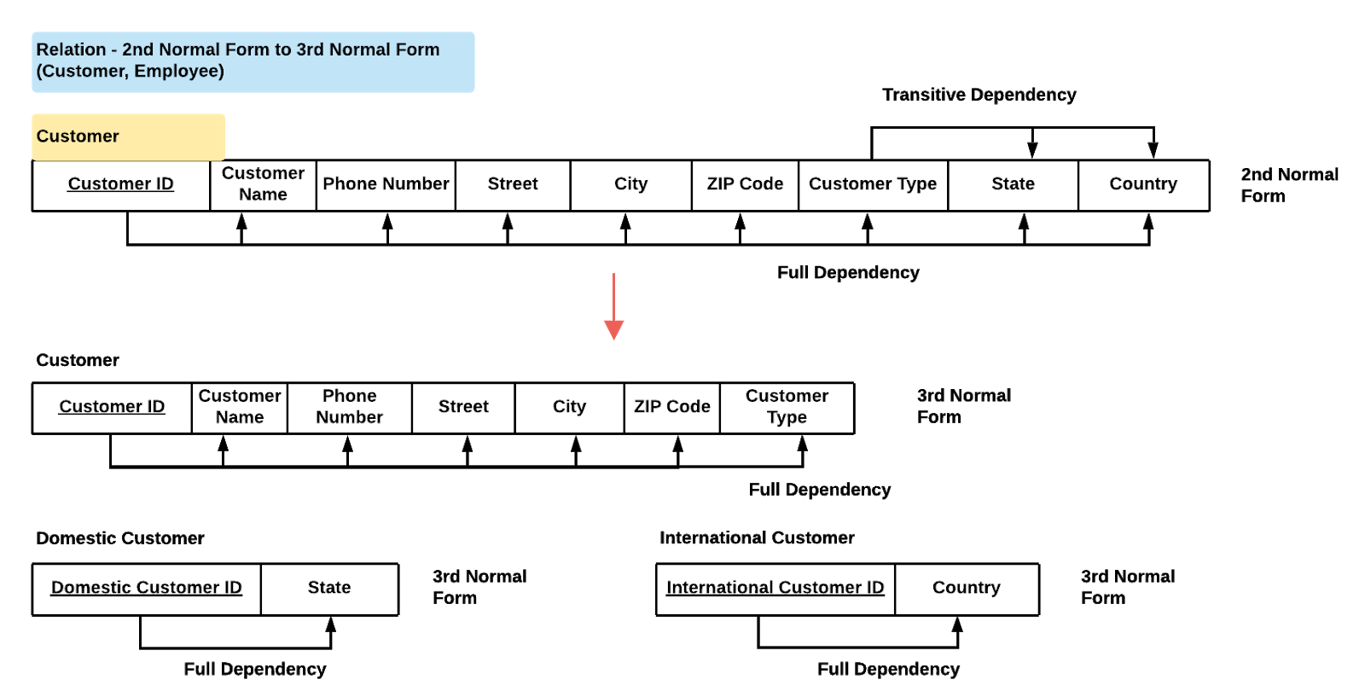

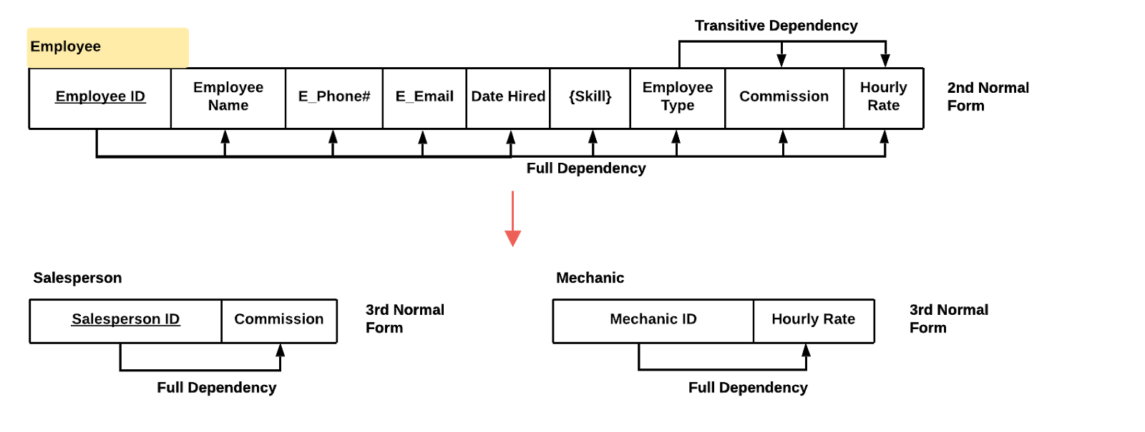

# Structured Query Language

## Creation Script

-- customer table

CREATE TABLE IF NOT EXISTS customer

(

customer_id INTEGER NOT NULL,

customer_name TEXT NOT NULL,

customer_phone_number VARCHAR(30) NOT NULL,

customer_street TEXT NOT NULL,

customer_city TEXT NOT NULL,

customer_zip_code VARCHAR(20) NOT NULL,

customer_type TEXT NOT NULL,

PRIMARY KEY (customer_id),

CHECK ( customer_type = 'international' or customer_type = 'domestic')

);

-- domestic customer table subtype of customer

CREATE TABLE IF NOT EXISTS domestic_customer

(

domestic_customer_id INTEGER NOT NULL,

domestic_customer_state VARCHAR(2) NOT NULL,

PRIMARY KEY (domestic_customer_id),

FOREIGN KEY (domestic_customer_id) REFERENCES customer (customer_id)

);

-- international customer table with subtype of customer

CREATE TABLE IF NOT EXISTS international_customer

(

international_customer_id INTEGER NOT NULL,

international_customer_country TEXT NOT NULL,

PRIMARY KEY (international_customer_id),

FOREIGN KEY (international_customer_id) REFERENCES customer (customer_id)

);

-- create employee table

CREATE TABLE IF NOT EXISTS employee

(

employee_ID INTEGER NOT NULL,

employee_name TEXT NOT NULL,

employee_phone_number VARCHAR(30) NOT NULL,

employee_email TEXT NOT NULL,

employee_date_hired DATE DEFAULT CURRENT_DATE NOT NULL,

employee_type TEXT NOT NULL,

PRIMARY KEY (employee_ID),

CHECK ( employee_type = 'sales' or employee_type = 'mechanic')

);

-- create mechanic table subtype of employee

CREATE TABLE IF NOT EXISTS mechanic

(

employee_id INTEGER NOT NULL,

mechanic_hourly_rate FLOAT NOT NULL,

PRIMARY KEY (employee_id),

FOREIGN KEY (employee_id) REFERENCES employee (employee_ID)

);

-- sales person table subtype of employee

CREATE TABLE IF NOT EXISTS sales_person

(

employee_id INTEGER NOT NULL,

sales_person_commission FLOAT NOT NULL,

PRIMARY KEY (employee_id),

FOREIGN KEY (employee_id) REFERENCES employee (employee_ID)

);

-- employee skill multi valued table

CREATE TABLE IF NOT EXISTS employee_skill

(

employee_id INTEGER NOT NULL,

employee_skill TEXT NOT NULL,

PRIMARY KEY (employee_id, employee_skill),

FOREIGN KEY (employee_id) REFERENCES employee (employee_ID)

);

-- orders table

CREATE TABLE IF NOT EXISTS orders

(

order_id INTEGER NOT NULL,

order_placement_date DATE DEFAULT CURRENT_DATE NOT NULL,

order_shipment_date DATE,

customer_id INTEGER NOT NULL,

primary key (order_id),

FOREIGN KEY (customer_id) REFERENCES customer (customer_id)

);

-- vehicle table

CREATE TABLE IF NOT EXISTS vehicle

(

vehicle_id INTEGER NOT NULL,

vehicle_make TEXT NOT NULL,

vehicle_model TEXT NOT NULL,

vehicle_year INT NOT NULL,

vehicle_cost FLOAT NOT NULL,

sales_person_id INTEGER,

PRIMARY KEY (vehicle_id),

FOREIGN KEY (sales_person_id) REFERENCES sales_person (employee_id)

);

-- order line table

CREATE TABLE IF NOT EXISTS order_line

(

order_line_id INTEGER NOT NULL,

order_id INTEGER NOT NULL,

vehicle_id INTEGER NOT NULL,

order_quantity INT NOT NULL,

PRIMARY KEY (order_line_id),

FOREIGN KEY (order_id) REFERENCES orders (order_id),

FOREIGN KEY (vehicle_id) REFERENCES vehicle (vehicle_id)

);

-- service table

CREATE TABLE IF NOT EXISTS service

(

service_id INTEGER NOT NULL,

vehicle_id INTEGER NOT NULL,

service_mechanic_id INTEGER NOT NULL,

service_name TEXT NOT NULL,

service_date_started DATE DEFAULT CURRENT_DATE NOT NULL,

service_date_end DATE,

PRIMARY KEY (service_id),

FOREIGN KEY (vehicle_id) REFERENCES vehicle (vehicle_id),

FOREIGN KEY (service_mechanic_id) REFERENCES mechanic (employee_id)

);

-- supplier table

CREATE TABLE IF NOT EXISTS supplier

(

supplier_id INTEGER NOT NULL,

company_name TEXT NOT NULL,

supplier_phone_number VARCHAR(30) NOT NULL,

supplier_street TEXT NOT NULL,

supplier_city TEXT NOT NULL,

supplier_state VARCHAR(2),

supplier_zip_code INT NOT NULL,

PRIMARY KEY (supplier_id)

);

-- part table

CREATE TABLE IF NOT EXISTS part

(

part_id INTEGER NOT NULL,

part_name TEXT NOT NULL,

part_price FLOAT NOT NULL,

supplier_id INTEGER NOT NULL,

mechanic_id INTEGER NOT NULL,

primary key (part_id),

FOREIGN KEY (supplier_id) REFERENCES supplier (supplier_id),

FOREIGN KEY (mechanic_id) REFERENCES mechanic (employee_id)

);

## Insertion

### Customer

INSERT INTO customer(customer_name, customer_phone_number, customer_street, customer_city, customer_zip_code,

customer_type)

VALUES ('Aaron Fuller', 7383670449, 'Pennsylvania Avenue', 19002, 'Grant', 'domestic');

INSERT INTO customer(customer_name, customer_phone_number, customer_street, customer_city, customer_zip_code,

customer_type)

VALUES ('Antonio Gross', 6674435742, 'Main customer_street South', 20744, 'Higganum', 'domestic');

INSERT INTO customer(customer_name, customer_phone_number, customer_street, customer_city, customer_zip_code,

customer_type)

VALUES ('Celia Young', 4238425859, 'Church customer_street', 30741, 'Wood River', 'domestic');

INSERT INTO customer(customer_name, customer_phone_number, customer_street, customer_city, customer_zip_code,

customer_type)

VALUES ('Wilson Goodwin', 5548581699, 'Fairview Avenue', 'Roy', 45840, 'domestic');

INSERT INTO customer(customer_name, customer_phone_number, customer_street, customer_city, customer_zip_code,

customer_type)

VALUES ('Leo Gill', 7184528143, 'Wall customer_street', 'Montross', 07026, 'domestic');

INSERT INTO customer(customer_name, customer_phone_number, customer_street, customer_city, customer_zip_code,

customer_type)

VALUES ('Reginald Hogan', 2833381181, 'Hudson customer_street', 'Marco Island', 11542, 'international');

INSERT INTO customer(customer_name, customer_phone_number, customer_street, customer_city, customer_zip_code,

customer_type)

VALUES ('Elijah Joseph', 9239375532, 'Highland Avenue', 'Virgelle', 27526, 'international');

INSERT INTO customer(customer_name, customer_phone_number, customer_street, customer_city, customer_zip_code,

customer_type)

VALUES ('Katie Brady', 3958198655, 'Dogwood Drive', 'Bienville', 16506, 'international');

INSERT INTO customer(customer_name, customer_phone_number, customer_street, customer_city, customer_zip_code,

customer_type)

VALUES ('Mona Drake', 2179153374, 'Heritage Drive', 'Carthage', 08527, 'international');

INSERT INTO customer(customer_name, customer_phone_number, customer_street, customer_city, customer_zip_code,

customer_type)

VALUES ('Derrick Summers', 9768634277, '4th customer_street', 'Floyd', 07726, 'international');

### Domestic Customer

INSERT INTO domestic_customer(domestic_customer_id, domestic_customer_state)

VALUES (1, 'CA');

INSERT INTO domestic_customer(domestic_customer_id, domestic_customer_state)

VALUES (2, 'NY');

INSERT INTO domestic_customer(domestic_customer_id, domestic_customer_state)

VALUES (3, 'NV');

INSERT INTO domestic_customer(domestic_customer_id, domestic_customer_state)

VALUES (4, 'MA');

INSERT INTO domestic_customer(domestic_customer_id, domestic_customer_state)

VALUES (5, 'CA');

### International Customer

INSERT INTO international_customer(international_customer_id, international_customer_country)

VALUES (6, 'Chile');

INSERT INTO international_customer(international_customer_id, international_customer_country)

VALUES (7, 'France');

INSERT INTO international_customer(international_customer_id, international_customer_country)

VALUES (8, 'Greece');

INSERT INTO international_customer(international_customer_id, international_customer_country)

VALUES (9, 'Japan');

INSERT INTO international_customer(international_customer_id, international_customer_country)

VALUES (10, 'Mexico');

### Employee

INSERT INTO employee(employee_name, employee_phone_number, employee_email, employee_date_hired, employee_type)

VALUES ('Abraham Kennedy', 5974784359, 'tmaek@me.com', '2017-04-01', 'sales');

INSERT INTO employee(employee_name, employee_phone_number, employee_email, employee_date_hired, employee_type)

VALUES ('Lorene Cannon', 6128891387, 'wmszeliga@mac.com', '2011-04-01', 'sales');

INSERT INTO employee(employee_name, employee_phone_number, employee_email, employee_date_hired, employee_type)

VALUES ('Ronald Saunders', 7203219940, 'johndo@yahoo.ca', '2012-04-01', 'sales');

INSERT INTO employee(employee_name, employee_phone_number, employee_email, employee_date_hired, employee_type)

VALUES ('Nicole Webb', 3698455909, 'quinn@gmail.com', '2013-04-01', 'sales');

INSERT INTO employee(employee_name, employee_phone_number, employee_email, employee_date_hired, employee_type)

VALUES ('Beatrice Morrison', 3188742111, 'shang@comcast.net', '2017-04-01', 'sales');

INSERT INTO employee(employee_name, employee_phone_number, employee_email, employee_date_hired, employee_type)

VALUES ('Charlene Williams', 6958416474, 'stecoop@optonline.net', '2014-04-01', 'mechanic');

INSERT INTO employee(employee_name, employee_phone_number, employee_email, employee_date_hired, employee_type)

VALUES ('Arlene Lyons', 6194572578, 'speeves@verizon.net', '2015-04-01', 'mechanic');

INSERT INTO employee(employee_name, employee_phone_number, employee_email, employee_date_hired, employee_type)

VALUES ('Antonia Barton', 4488908506, 'mwitte@optonline.net', '2012-04-01', 'mechanic');

INSERT INTO employee(employee_name, employee_phone_number, employee_email, employee_date_hired, employee_type)

VALUES ('Cristina Chandler', 3754965474, 'squirrel@yahoo.ca', '2014-04-01', 'mechanic');

INSERT INTO employee(employee_name, employee_phone_number, employee_email, employee_date_hired, employee_type)

VALUES ('Ronnie Ferguson', 2932422652, 'skippy@yahoo.com', '2018-04-01', 'mechanic');

### Employee Skills

INSERT INTO employee_skill (employee_id, employee_skill)

VALUES (1, 'Product Knowledge');

INSERT INTO employee_skill (employee_id, employee_skill)

VALUES (1, 'Strategic Prospecting employee_skills');

INSERT INTO employee_skill (employee_id, employee_skill)

VALUES (1, 'Active Listening');

INSERT INTO employee_skill (employee_id, employee_skill)

VALUES (2, 'Product Knowledge');

INSERT INTO employee_skill (employee_id, employee_skill)

VALUES (2, 'Communication');

INSERT INTO employee_skill (employee_id, employee_skill)

VALUES (2, 'Qualification Questioning');

INSERT INTO employee_skill (employee_id, employee_skill)

VALUES (3, 'Objection Handling');

INSERT INTO employee_skill (employee_id, employee_skill)

VALUES (3, 'Strategic Prospecting employee_skills');

INSERT INTO employee_skill (employee_id, employee_skill)

VALUES (3, 'Rapport Building on the Call');

INSERT INTO employee_skill (employee_id, employee_skill)

VALUES (3, 'Qualification Questioning');

INSERT INTO employee_skill (employee_id, employee_skill)

VALUES (4, 'Product Knowledge');

INSERT INTO employee_skill (employee_id, employee_skill)

VALUES (4, 'Buyer-Seller Agreement');

INSERT INTO employee_skill (employee_id, employee_skill)

VALUES (5, 'Objection Handling');

INSERT INTO employee_skill (employee_id, employee_skill)

VALUES (5, 'Objection Prevention');

INSERT INTO employee_skill (employee_id, employee_skill)

VALUES (5, 'Communication');

INSERT INTO employee_skill (employee_id, employee_skill)

VALUES (6, 'Diagnostic employee_skills');

INSERT INTO employee_skill (employee_id, employee_skill)

VALUES (6, 'Customer service employee_skills');

INSERT INTO employee_skill (employee_id, employee_skill)

VALUES (6, 'Problem-solving employee_skills');

INSERT INTO employee_skill (employee_id, employee_skill)

VALUES (6, 'Technical aptitude');

INSERT INTO employee_skill (employee_id, employee_skill)

VALUES (7, 'Customer service employee_skills');

INSERT INTO employee_skill (employee_id, employee_skill)

VALUES (7, 'Diagnostic employee_skills');

INSERT INTO employee_skill (employee_id, employee_skill)

VALUES (7, 'Technical aptitude');

INSERT INTO employee_skill (employee_id, employee_skill)

VALUES (7, 'Problem-solving employee_skills');

INSERT INTO employee_skill (employee_id, employee_skill)

VALUES (8, 'Customer service employee_skills');

INSERT INTO employee_skill (employee_id, employee_skill)

VALUES (8, 'Diagnostic employee_skills');

INSERT INTO employee_skill (employee_id, employee_skill)

VALUES (9, 'Problem-solving employee_skills');

INSERT INTO employee_skill (employee_id, employee_skill)

VALUES (9, 'Technical aptitude');

INSERT INTO employee_skill (employee_id, employee_skill)

VALUES (10, 'Customer service employee_skills');

INSERT INTO employee_skill (employee_id, employee_skill)

VALUES (10, 'Diagnostic employee_skills');

INSERT INTO employee_skill (employee_id, employee_skill)

VALUES (10, 'Technical aptitude');

INSERT INTO employee_skill (employee_id, employee_skill)

VALUES (10, 'Problem-solving employee_skills');

### Sales Person

INSERT INTO sales_person (employee_id, sales_person_commission)

VALUES (1, 5634.12);

INSERT INTO sales_person (employee_id, sales_person_commission)

VALUES (2, 5799.83);

INSERT INTO sales_person (employee_id, sales_person_commission)

VALUES (3, 8514.22);

INSERT INTO sales_person (employee_id, sales_person_commission)

VALUES (4, 8730.48);

INSERT INTO sales_person (employee_id, sales_person_commission)

VALUES (5, 4355.93);

### Mechanic

INSERT INTO mechanic (employee_id, mechanic_hourly_rate)

VALUES (6, 40.74);

INSERT INTO mechanic (employee_id, mechanic_hourly_rate)

VALUES (7, 37.45);

INSERT INTO mechanic (employee_id, mechanic_hourly_rate)

VALUES (8, 50.87);

INSERT INTO mechanic (employee_id, mechanic_hourly_rate)

VALUES (9, 43.71);

INSERT INTO mechanic (employee_id, mechanic_hourly_rate)

VALUES (10, 30.86);

### Vehicles

INSERT INTO vehicle (vehicle_make, vehicle_model, vehicle_year, vehicle_cost)

VALUES ('Cool', 'TT1', 2015, 32000);

INSERT INTO vehicle (vehicle_make, vehicle_model, vehicle_year, vehicle_cost)

VALUES ('Cool', 'TT2', 2017, 34000);

INSERT INTO vehicle (vehicle_make, vehicle_model, vehicle_year, vehicle_cost)

VALUES ('Cool', 'TT3', 2018, 39000);

INSERT INTO vehicle (vehicle_make, vehicle_model, vehicle_year, vehicle_cost)

VALUES ('Cool', 'ST1', 2014, 42000);

INSERT INTO vehicle (vehicle_make, vehicle_model, vehicle_year, vehicle_cost)

VALUES ('Cool', 'ST2', 2016, 45000);

INSERT INTO vehicle (vehicle_make, vehicle_model, vehicle_year, vehicle_cost)

VALUES ('Cool', 'GT1', 2012, 72000);

INSERT INTO vehicle (vehicle_make, vehicle_model, vehicle_year, vehicle_cost)

VALUES ('Cool', 'GT2', 2014, 112000);

INSERT INTO vehicle (vehicle_make, vehicle_model, vehicle_year, vehicle_cost)

VALUES ('Cool', 'GT3', 2016, 202000);

INSERT INTO vehicle (vehicle_make, vehicle_model, vehicle_year, vehicle_cost)

VALUES ('Cool', 'FF', 2019, 332000);

INSERT INTO vehicle (vehicle_make, vehicle_model, vehicle_year, vehicle_cost)

VALUES ('Cool', 'FFS', 2020, 352000);

INSERT INTO vehicle (vehicle_make, vehicle_model, vehicle_year, vehicle_cost, sales_person_id)

VALUES ('Giorgia', 'NINJA', 2017, 417826.20, 1);

INSERT INTO vehicle (vehicle_make, vehicle_model, vehicle_year, vehicle_cost, sales_person_id)

VALUES ('Pugito', 'Tumbler', 2018, 145842.20, 2);

INSERT INTO vehicle (vehicle_make, vehicle_model, vehicle_year, vehicle_cost, sales_person_id)

VALUES ('Cocanita', 'Titan', 2018, 18721.22, 3);

INSERT INTO vehicle (vehicle_make, vehicle_model, vehicle_year, vehicle_cost, sales_person_id)

VALUES ('EA', 'Cheetah', 2019, 18721.22,3);

INSERT INTO vehicle (vehicle_make, vehicle_model, vehicle_year, vehicle_cost, sales_person_id)

VALUES ('UBOAT', 'Ship', 2019, 24892.20, 4);

INSERT INTO vehicle (vehicle_make, vehicle_model, vehicle_year, vehicle_cost, sales_person_id)

VALUES ('HIT', 'Rocket', 2019, 24892.20, 4);

INSERT INTO vehicle (vehicle_make, vehicle_model, vehicle_year, vehicle_cost, sales_person_id)

VALUES ('SHIP', 'Delta', 2019, 5782.20, 5);

### Order

INSERT INTO orders (order_id, order_placement_date, order_shipment_date, customer_id)

VALUES (1, '2018-03-15', '2018-03-17', 1);

INSERT INTO orders (order_id, order_placement_date, order_shipment_date, customer_id)

VALUES (2, '2018-03-15', '2018-03-17', 1);

INSERT INTO orders (order_id, order_placement_date, order_shipment_date, customer_id)

VALUES (3, '2018-04-25', '2018-05-3', 2);

INSERT INTO orders (order_id, order_placement_date, order_shipment_date, customer_id)

VALUES (4, '2018-05-06', '2018-05-06', 3);

INSERT INTO orders (order_id, order_placement_date, order_shipment_date, customer_id)

VALUES (5, '2018-08-29', '2018-09-03', 3);

INSERT INTO orders (order_id, order_placement_date, order_shipment_date, customer_id)

VALUES (6, '2018-010-17', '2018-10-27', 4);

INSERT INTO orders (order_id, order_placement_date, order_shipment_date, customer_id)

VALUES (7, '2018-11-05', '2018-11-07', 5);

INSERT INTO orders (order_id, order_placement_date, order_shipment_date, customer_id)

VALUES (8, '2018-12-05', '2018-12-07', 6);

INSERT INTO orders (order_id, order_placement_date, order_shipment_date, customer_id)

VALUES (9, '2019-04-16', '2019-04-17', 7);

INSERT INTO orders (order_id, order_placement_date, order_shipment_date, customer_id)

VALUES (10, '2019-04-17', '2019-04-20', 8);

### Order Line

INSERT INTO order_line (order_id, vehicle_id, order_quantity)

VALUES (1, 4, 8);

INSERT INTO order_line (order_id, vehicle_id, order_quantity)

VALUES (2, 1, 24);

INSERT INTO order_line (order_id, vehicle_id, order_quantity)

VALUES (3, 1, 32);

INSERT INTO order_line (order_id, vehicle_id, order_quantity)

VALUES (4, 4, 8);

INSERT INTO order_line (order_id, vehicle_id, order_quantity)

VALUES (5, 6, 2);

INSERT INTO order_line (order_id, vehicle_id, order_quantity)

VALUES (6, 2, 40);

INSERT INTO order_line (order_id, vehicle_id, order_quantity)

VALUES (7, 3, 3);

INSERT INTO order_line (order_id, vehicle_id, order_quantity)

VALUES (8, 5, 1);

INSERT INTO order_line (order_id, vehicle_id, order_quantity)

VALUES (9, 3, 5);

INSERT INTO order_line (order_id, vehicle_id, order_quantity)

VALUES (10, 5, 4);

### Supplier

INSERT INTO supplier (company_name, supplier_phone_number, supplier_street, supplier_city, supplier_state,

supplier_zip_code)

VALUES ('Audi', 6387622055, '71 Livingston St', 'Charlotte', 'NC', 28205);

INSERT INTO supplier (company_name, supplier_phone_number, supplier_street, supplier_city, supplier_state,

supplier_zip_code)

VALUES ('Bosche', 7017801479, '87 Oak Valley Road', 'Brainerd', 'MN', 56401);

INSERT INTO supplier (company_name, supplier_phone_number, supplier_street, supplier_city, supplier_state,

supplier_zip_code)

VALUES ('Titan', 9468600631, '7897 Roosevelt St.', 'Massapequa', 'NY', 11758);

INSERT INTO supplier (company_name, supplier_phone_number, supplier_street, supplier_city, supplier_state,

supplier_zip_code)

VALUES ('YOKOHOMA', 5543431211, '784 High Noon St.', 'Solon', 'OH', 44139);

INSERT INTO supplier (company_name, supplier_phone_number, supplier_street, supplier_city, supplier_state,

supplier_zip_code)

VALUES ('YAMAZAKI', 9297542285, '7922 Roosevelt Ave.', 'Ridgewood', 'NJ', 07450);

INSERT INTO supplier (company_name, supplier_phone_number, supplier_street, supplier_city, supplier_state,

supplier_zip_code)

VALUES ('S1 moto sport club', 3887319886, '8904 Armstrong Lane', 'Montclair', 'NJ', 07042);

INSERT INTO supplier (company_name, supplier_phone_number, supplier_street, supplier_city, supplier_state,

supplier_zip_code)

VALUES ('Bazuka', 5262312635, '44 Morris Ave', 'Westport', 'CT', 06880);

INSERT INTO supplier (company_name, supplier_phone_number, supplier_street, supplier_city, supplier_state,

supplier_zip_code)

VALUES ('AMD', 6999955820, '935 St Margarets Drive', 'Millington', 'TN', 38053);

INSERT INTO supplier (company_name, supplier_phone_number, supplier_street, supplier_city, supplier_state,

supplier_zip_code)

VALUES ('GRID', 3964893814, '8877 Snake Hill supplier_street', 'Fall River', 'MA', 02720);

INSERT INTO supplier (company_name, supplier_phone_number, supplier_street, supplier_city, supplier_state,

supplier_zip_code)

VALUES ('TOYO', 2136244983, '8135 South Ave', 'Ellicott supplier_city', 'MD', 21042);

### Part

INSERT INTO part (part_name, part_price, supplier_id, mechanic_id)

VALUES ('Audi sport suspension', 1800, 1, 6);

INSERT INTO part (part_name, part_price, supplier_id, mechanic_id)

VALUES ('Bosch moto oil', 89, 2, 6);

INSERT INTO part (part_name, part_price, supplier_id, mechanic_id)

VALUES ('Drift LSD', 3200, 3, 7);

INSERT INTO part (part_name, part_price, supplier_id, mechanic_id)

VALUES ('performance tires', 1400, 4, 7);

INSERT INTO part (part_name, part_price, supplier_id, mechanic_id)

VALUES ('Anti-roll bar', 900, 5, 8);

INSERT INTO part (part_name, part_price, supplier_id, mechanic_id)

VALUES ('Brambo brake system', 3000, 6, 8);

INSERT INTO part (part_name, part_price, supplier_id, mechanic_id)

VALUES ('B Turbo', 5600, 7, 9);

INSERT INTO part (part_name, part_price, supplier_id, mechanic_id)

VALUES ('ECU unit', 4000, 8, 9);

INSERT INTO part (part_name, part_price, supplier_id, mechanic_id)

VALUES ('Suports package', 7000, 9, 10);

INSERT INTO part (part_name, part_price, supplier_id, mechanic_id)

VALUES ('Grip tires', 900, 10, 10);

### Service

INSERT INTO service(vehicle_id, service_mechanic_id, service_name, service_date_started, service_date_end)

VALUES (6, 6, 'suspension check', '2019-3-12', '2019-3-12');

INSERT INTO service(vehicle_id, service_mechanic_id, service_name, service_date_started, service_date_end)

VALUES (2, 6, 'oil change', '2019-3-21', '2019-3-21');

INSERT INTO service(vehicle_id, service_mechanic_id, service_name, service_date_started, service_date_end)

VALUES (3, 7, 'oil change', '2019-3-25', '2019-3-25');

INSERT INTO service(vehicle_id, service_mechanic_id, service_name, service_date_started, service_date_end)

VALUES (2, 7, 'air filter upgrade', '2019-4-02', '2019-4-22');

INSERT INTO service(vehicle_id, service_mechanic_id, service_name, service_date_started, service_date_end)

VALUES (1, 8, 'coolant change', '2019-4-12', '2019-4-13');

INSERT INTO service(vehicle_id, service_mechanic_id, service_name, service_date_started, service_date_end)

VALUES (6, 8, 'transmission replace', '2019-4-15', '2019-4-19');

INSERT INTO service(vehicle_id, service_mechanic_id, service_name, service_date_started, service_date_end)

VALUES (1, 9, 'suspension change', '2019-4-22', '2019-4-24');

INSERT INTO service(vehicle_id, service_mechanic_id, service_name, service_date_started, service_date_end)

VALUES (4, 9, 'CV joint change', '2019-5-8', '2019-5-12');

INSERT INTO service(vehicle_id, service_mechanic_id, service_name, service_date_started, service_date_end)

VALUES (5, 10, 'turbo maintenance', '2019-5-18', '2019-5-19');

INSERT INTO service(vehicle_id, service_mechanic_id, service_name, service_date_started, service_date_end)

VALUES (3, 10, 'oil change', '2019-6-22', '2019-6-22');

## Queries and Result

## List All Domestic Customers

SELECT *  
FROM customer

WHERE customer_type = 'domestic';

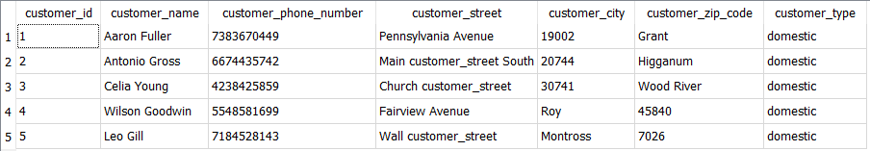

## List all the employee IDs, names, and dates of employees who were hired before the end of May 2015

SELECT employee_id, employee_name, employee_date_hired

FROM employee

WHERE employee_date_hired <= '2015-05-30'

ORDER BY employee_date_hired DESC;

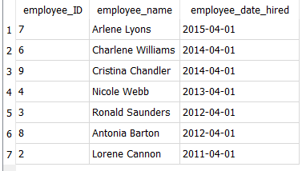

## List all employee ID and names of employees who have more than 2 skills

SELECT employee.employee_id, employee.employee_name, COUNT(employee_skill.employee_id) AS number_of_skills

FROM employee,  
 employee_skill WHERE employee_skill.employee_id = employee.employee_id GROUP BY employee.employee_id

HAVING count(employee_skill.employee_id) > 2;

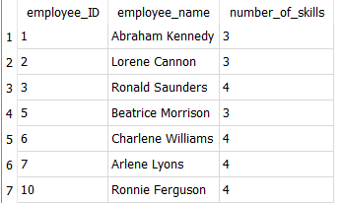

## List all Japanese customers

SELECT customer_id,  
 international_customer_country,  
 customer_name,  
 customer_phone_number,  
 customer_street,  
 customer_city,  
 customer_zip_code,  
 customer_type

FROM international_customer

INNER JOIN customer ON international_customer.international_customer_id = customer.customer_id

WHERE international_customer_country = 'Japan';



## List customer ID, customer name, customer type, and how many orders each customer placed

SELECT customer.customer_id, customer_name, customer_type, COUNT(orders.customer_id) AS order_number

FROM customer

LEFT JOIN orders

ON customer.customer_id = orders.customer_id

GROUP BY customer.customer_id;

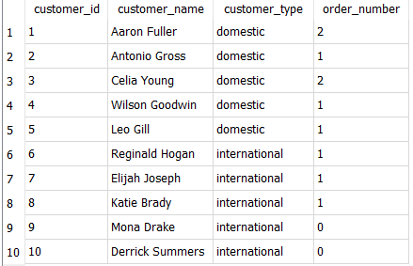

## Which vehicle ID, make, model, year, are priced above the average cost of our cars, and how much are they?

SELECT vehicle_id, vehicle_make, vehicle_model, vehicle_year, vehicle_cost FROM vehicle

WHERE vehicle_cost >

(  
 SELECT AVG(vehicle_cost)  
 FROM vehicle

);

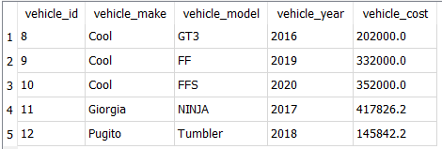

## Find out vehicle make, model which were made after 2015, and all the service info from the vehicle and service table.

SELECT vehicle.vehicle_make, vehicle.vehicle_model, vehicle.vehicle_year, service.*  
FROM vehicle

INNER JOIN service ON vehicle.vehicle_id = service.vehicle_id

WHERE vehicle_year > '2015'

ORDER BY service.vehicle_id;

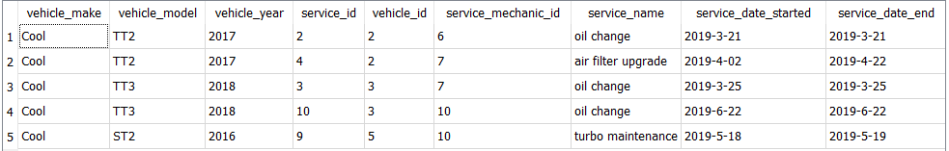

## Which mechanic has an hourly rate of higher than $40, and works with parts that cost less than $3,000 and what are those parts called? List Mechanic employee ID and hourly rate

SELECT employee_id, mechanic_hourly_rate, part_name, part_price

FROM mechanic

LEFT JOIN part ON employee_id = mechanic_id

WHERE mechanic_hourly_rate > 40

AND employee_id =  
 (  
 SELECT mechanic_id

FROM part

WHERE part_price < 3000

)  
ORDER BY employee_id;

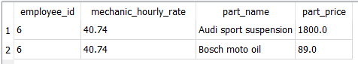

## Find out the sales person's average rate of commission of total vehicle cost

SELECT AVG(sales_person_commission) / AVG(vehicle_cost)  
FROM sales_person, vehicle;



## How many cars are priced less than the average price of our cars?

SELECT COUNT(*)  
FROM vehicle

WHERE vehicle_cost <

(  
 SELECT AVG(vehicle_cost)  
 FROM vehicle

)



## What percentage of cars are priced less than the average price? Round to 2 decimal places.

SELECT (ROUND(((CAST((SELECT COUNT(*)  
FROM vehicle

WHERE vehicle_cost < (SELECT AVG(vehicle_cost) FROM vehicle)) AS FLOAT) /  
 CAST((SELECT COUNT(*) FROM vehicle) AS FLOAT))) * 100, 2)) AS cars_priced_less_than_average;

